**Modules, formats, and loaders**

A rundown of module formats (syntax), loaders (like RequireJS), and modules that fit these patterns.

**Format vs. Loader**

* A ***module format*** is the syntax used to define a module, independent of any loader.
* A ***module loader*** are JS libraries that understand the module format you’re using and how to load and execute them.

Like there are many browsers that interpret JS, there are multiple libraries that interpret modules in each format (AMD below).

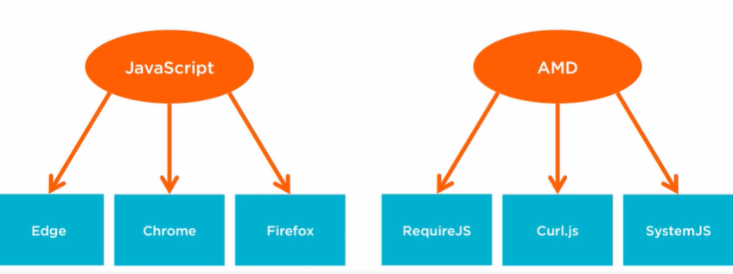

**5 Common formats:**

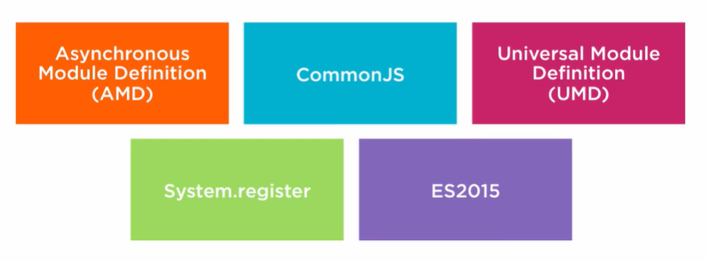

* **AMD** allows for asynchronous module loading, and is used at the front-end in browsers.
* **CommonJS** is often used for loading modules into back-end apps, like node.js REST APIs.
* **UMD** seeks to produce modules readable by loaders from the above two – not common.
* **System.register** works with the SystemJS module formatter, although this also takes other formats.
* **ES2015** also implemented native modules and module loading. Don’t know if this was ever actually used much, this tutorial was created in 2015!

**Module Loaders: RequireJS and SystemJS**

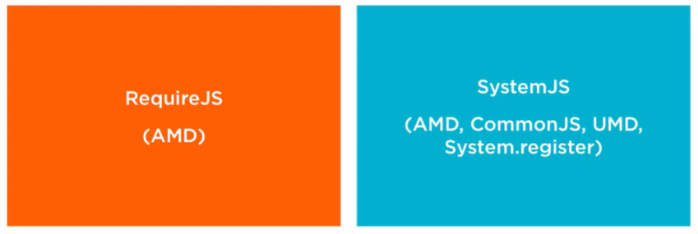

* **RequireJS** is a very popular loader for using AMD modules in a browser.
* **SystemJS** is also very popular, and nice because it loads up tons of formats!